The Burley Line

Suggested Cover Picture goes here
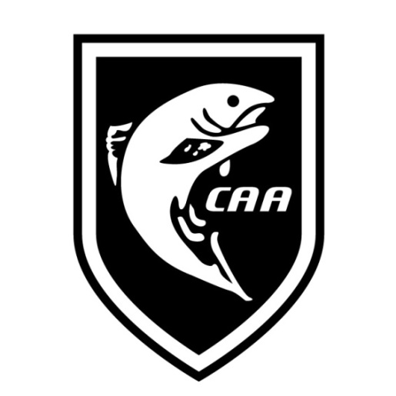

Newsletter of the Canberra Anglers Association Inc.
From the Editor’s Desk
An opportunity to speak to your readers.
Coming Events
Meeting: date.
As usual 7:30 at Raiders Weston.
Fly – Tying date.
As usual 7:30 via Zoom – more details in due course via email.
Next Events
date – description.
Title.
Author
Words and photos.

The sections below are optional as they take a bit of fiddling.

Stuff You May Have Already Read on our News Blog
Don’t forget that you can register to receive automatic emails when new posts are uploaded. Fill out the form on the right of any post. These notifications can be very informative, for instance a previous invitation to head up to Eucumbene to see some brook trout being translocated, also the notification about a series of webinars on native fish initiatives on the ‘Bidgee.
Title with Hotlink
summary.
Stuff You May Have Already Read on our Facebook Page
If you are on Facebook, you should consider “liking and following” the CAA Facebook page.
For those of you who don’t subscribe to Facebook, click on headings below to look at the post – you don’t need to join Facebook. Facebook is a fast moving medium so I’ll only be putting stuff here in Burley Line that is of a longer-term interest – often that’ll mean nothing in any particular month, but I’ll keep the placemarker.
Title with Hotlink
summary.
Other News
Additional news and links from supporting groups
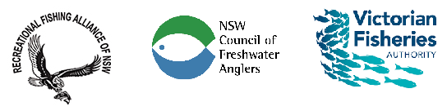
NSW Council of Freshwater Anglers
Remember you can subscribe to the Newsletter (Freshwater Fisher) yourself, there is a link in every monthly newsletter. Previous CFA newsletters can be accessed via their archive. They also have a presence on Facebook. The key correspondence, a useful calendar of events and recent videos are on their website.
Don’t forget you can donate to the CFA by becoming a ‘Foundation Member’ and personally support their good work. The website explains– only the equivalent of $0.50 per week.

Recreational Fishing Alliance of NSW
Remember you can subscribe yourself, there is a link in every monthly newsletter. Recent, previous RFA newsletters can be accessed via their archive. They also have a presence on Facebook.
Fisheries Victoria News – ‘Nibbles’
These are in hiatus for the moment while they identify a new distribution system. Meanwhile they have a presence on all forms of social media.
Long Term Program of Events Not Formally Part of CAA Events
Provided for your calendar planning, members can see the diversity of angling events available to attend and some might even choose to get a CAA group together to attend an event outside our formal calendar which would broaden our horizons greatly. If anyone spots a non-CAA event that might be of interest to members, please email Burley Line.

Dates | Event Details
various | The NSW DPI Kids’ Fishing Workshops at Gaden Hatchery Jindabyne are in hiatus while the refurbishment program is in train. However there are also saltwater and freshwater events across the state.  https://www.dpi.nsw.gov.au/fishing/recreational/resources/fishing-workshops/kids
Friday 22nd Nov 2024 - Sunday 24th November 2024 | Buckenderra’s “Anaconda Trout Challenge”. For 2023 highlights see  https://www.facebook.com/100057227030541/posts/pfbid0BtH781hnBq3Ut4Ecm3qbQHnvvWj8FUUK9XQ7RBfUEyAsgffxh7UGUa66eiVSv6Dql/?mibextid=Nif5oz
Notable Fish Recorded
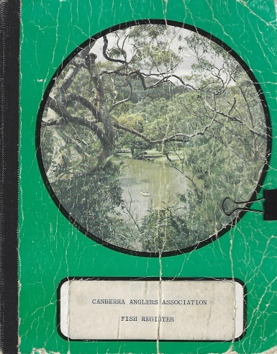
The intent of this segment is to encourage folk to get out fishing and share the joy. It is not the 'official record of catches' and so can include catches of interest that aren't eligible for trophies. Currently, the authoritative list for consideration for the club trophies is the little green book brought to meetings by the Secretary clearly marked as “Canberra Anglers Association Fish Register” pictured here. Please take photos of your catch with a tape or other verifiable measurement device (eg rod, but not your foot or hand).

We welcome emails advising how you are going, but don’t forget to formally register them. Please be aware that I tend to collect catch information from word of mouth and articles submitted for publication. I occasionally peruse the little green book, but inclusion in Burley Line can’t be interpreted as having been checked by me as being registered.

Angler | Species | Length | Method | Location/Event/ Date
Peter | Brown trout | 61cm (over 6lb! his heaviest Australian trout) | Fly | Lake Eucumbene, 28 Jul 2023
Peter | Brown trout | 48cm | Fly | Lake Eucumbene, 28 Jul 2023
Bill | Rainbow trout | 37cm | Dry Fly | Bondi Forest Lodge trip, 4 Aug 2023
Bill | Brown trout | 44cm | Fly | Lake Eucumbene, 13 Aug 2023
Bill | Brown trout | 57cm | Fly | An unnamed river on the Monaro, 1 Oct 2023
Peter | Golden Perch | 38cm  Scores 23% on our Native Fish Assessment | Fly | Lake Tuggeranong, 8 Oct 2023
Jayden | Rainbow | 33cm | Fly | Cotter River – Lyle Knowles 29 Oct
Ryan | Rainbow | 33cm | Fly | Cotter River – Lyle Knowles 29 Oct
Jayden | Rainbow | 33cm | Fly | Cotter River – Lyle Knowles 29 Oct
Lachy | Brown trout | 31cm | Fly | Cotter River – Lyle Knowles 29 Oct
Bill | Rainbow trout | 29cm | Fly | Cotter River – Lyle Knowles 29 Oct
Peter | Redfin Perch | 40cm | Fly | Lake Tuggeranong, 31 Oct 2023
Bill | Rainbow trout | 31 cm | Fly | Queanbeyan River 10 Nov
Rod | Mulloway | 62.5cm | Lure | Tuross Lake – Coast Event – 18 Nov
Bill | Flathead | A number at 43cm | Lure | Tuross Lake – Coast Event – 18 Nov
Peter | Carp | Ten up to 63cm | Bait | LBG – CAA Carp event 14 Jan

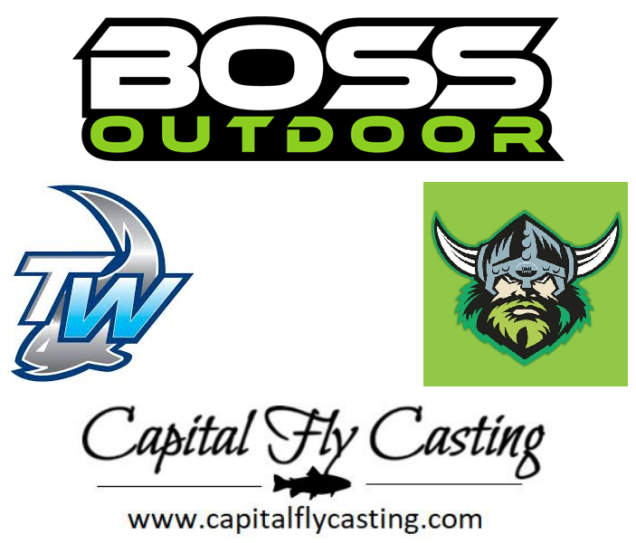
Join Us
Thinking of becoming a member? The membership application form can be found on our website. Fees are payable each year after our AGM (adjustments will be made for joining later in the year). 2023/2024 rates are unchanged from last year:
- General Membership $40.00
- Family Membership $50.00
- Concession Membership (age pension or concession card) $15.00
- Junior Membership (U18 years) $15.00
Payment can be made via bank transfer (details on the form) or in-person at one of our meetings.
For the rest of the year (ie until our AGM) new members are half the usual rate. More information on our website or email.
Contribute to The Burley Line
Contributions are always encouraged to The Burley Line and can be sent in via the email listed on the left (or via clicking the link on the web home page below “contact us”). Whether it be photos, trip reports, gear reviews, advertising, places to visit, we welcome it all.
Additionally, posts for our blog are also welcome, especially for our cooking page, gear notes and places to visit. Comments on individual blog posts are also encouraged.
Supporters
Canberra Anglers Association would like to thank the supporters below for their ongoing assistance to our club. We encourage all members to support these groups where possible.
Contact Us
Canberra Anglers Association Inc.
PO Box 4115
Hawker, ACT, 2614

Visit us on the web at
https://www.canberra-anglers.asn.au/

Burley Line contributions to:

NOTE: Apart from Official Club Policy or Official Reports, the views expressed in this newsletter are not necessarily those of the Canberra Anglers Association.

